Methodological approach — candidate territories
  - Mapping, high-sensitivity screening and suitability assessment
13 October 2026

Overview
Methodological description and criteria tables are available in English and Ukrainian. The linked documents have been updated to match this publication.
Визначаються території, непридатні для розміщення вітрових електростанцій через правові, екологічні або технічні обмеження.
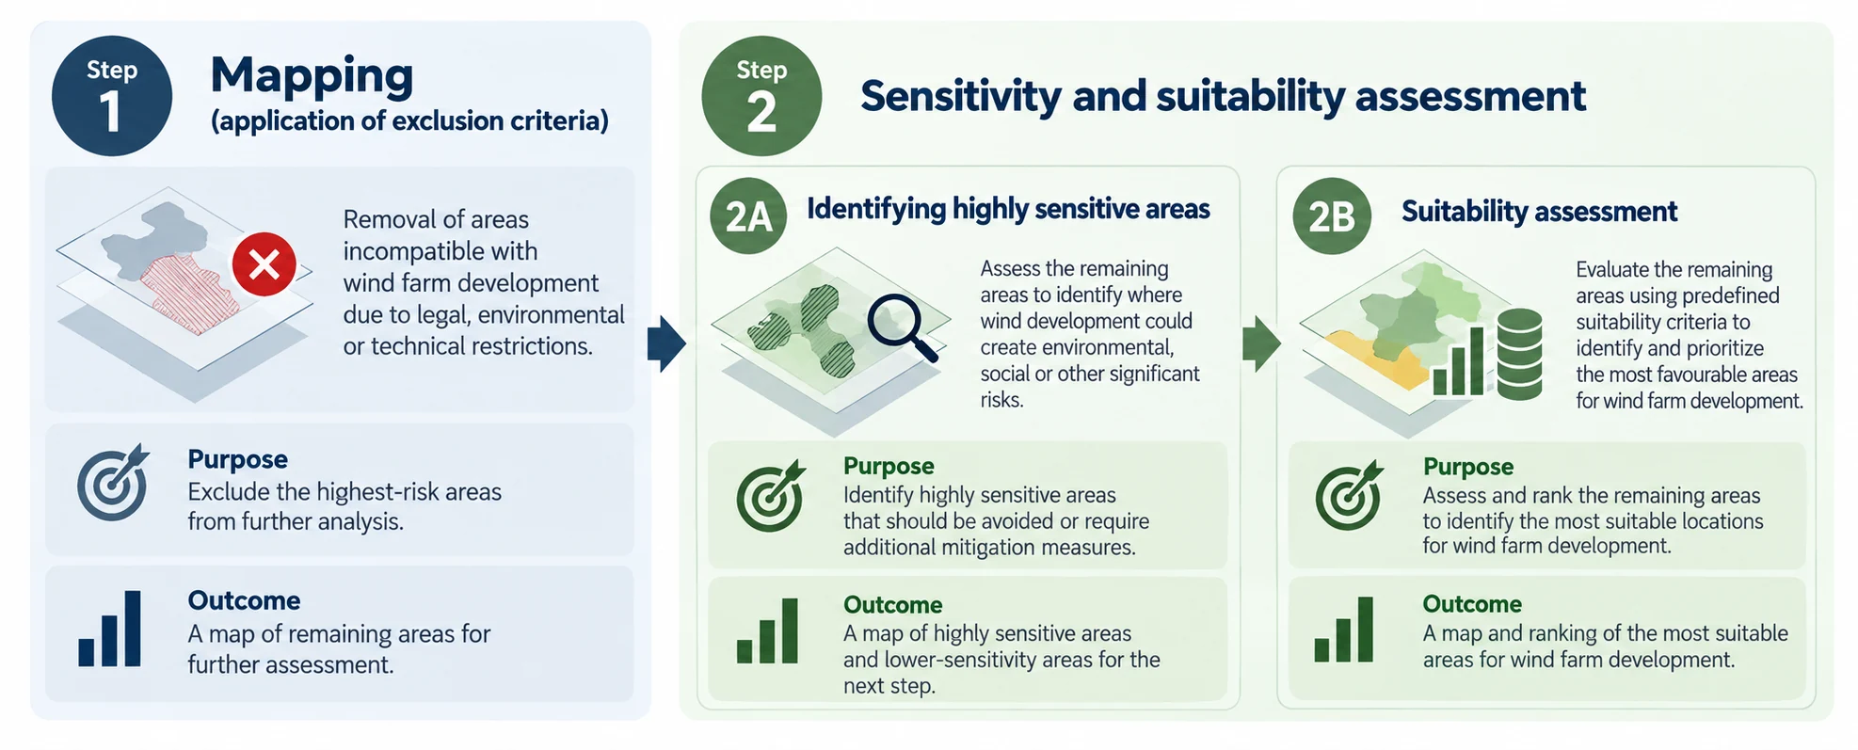

Step 1 — Mapping
During the mapping phase, exclusion criteria were applied to identify and remove areas where wind farm development could potentially result in significant adverse environmental, social, or other impacts, or where development would be incompatible with existing legal, environmental, or technical restrictions. These areas were excluded from further assessment.
The mapping process was based on the methodology and spatial information developed within the REZOMA project. As part of the preparatory work, the available spatial datasets were reviewed to identify opportunities to incorporate more accurate, up-to-date, or higher-resolution data, thereby improving the reliability and spatial precision of the assessment. In parallel, relevant legislation and regulatory requirements were reviewed to determine whether any additional exclusion criteria or changes to existing restrictions needed to be considered. This process ensured that the mapping approach was based on the best available spatial data, reflected the current regulatory framework, and provided a consistent and reliable basis for the subsequent sensitivity and suitability assessment (Step 2).
Stage 1 mapping criteria from the supplied Excel workbook. Buffer distances and listed data sources describe the methodological reference table; actual run settings are controlled by the selected scenario.
Data group | Criteria | Exclusion distance | Reference | Data source
Socioeconomic aspects | Cities and villages | 1500 m | Rezoma | OSM
Socioeconomic aspects | Residential and public buildings | 700 m | Ukrainian national standard | OSM
Socioeconomic aspects | Churches | 600 m | Rezoma | OSM
Socioeconomic aspects | Cultural heritage (National level) | 100 metres within settlements, · 300 metres outside settlements | Law "On Protection of Cultural Heritage" | Ministry of Culture
Socioeconomic aspects | UNESCO world heritage | UNESCO-defined buffer zones | Law "On Protection of Cultural Heritage" | UNESCO
Planning constraints and land use | Slope* | 15 degree | Rezoma | COPERNICUS
Planning constraints and land use | Elevation | > 1000 m | RES Law (1.10.2026) | COPERNICUS
Planning constraints and land use | Rivers and lakes | 400 m | Rezoma | State water cadastre
Planning constraints and land use | Sea (Coastal) | 2 km | Water Code of UA | OSM
Planning constraints and land use | Forest | 0 m | Rezoma | OSM
Planning constraints and land use | Heath | 0 m | Rezoma | OSM
Planning constraints and land use | Meadow | 0 m | Rezoma | OSM
Planning constraints and land use | Scrub | 0 m | Rezoma | OSM
Planning constraints and land use | Natural resource excavation areas | 500 m | Rezoma | OSM
Planning constraints and land use | Border strip | -2 km border with Russia and Belarus · -50 m other countries | Law "On the State Border of Ukraine" | PAEW
Infrastructure | Roads | 375 m | total h*1,5 | OSM
Infrastructure | Railways | 375 m | total h*1,5 | OSM
Infrastructure | Energy infrastructure - transmission lines and substations | 375 m | total h*1,5 | OSM
Infrastructure | Substations | > 20 km | Rezoma | OSM
Infrastructure | Gas and oil pipelines | 400 m | Law ‘On the Legal Status of Land in the Protection Zones of Main Pipeline Facilities’  (Article 11) | OSM
Infrastructure | Ammonia pipelines | 1000 m | Law ‘On the Legal Status of Land in the Protection Zones of Main Pipeline Facilities’  (Article 11) | OSM
Infrastructure | Airports | Large - 15 000 m · Small - 10 000 m | DBN Б.2.2-12:2019 ‘Land-use planning and development’, clause 11.2.9. | OurAirports (data provider website)
Infrastructure | Television and communication towers | 2000 m | DBN Б.2.2-12:2019 ‘Land-use planning and development’ | OSM
Nature values and biodiversity | Nationally and internationally protected areas | 1000 m | Rezoma | WDPA database
Wind | Wind potential | <3200 FLH | Rezoma | Global wind atlas

Step 2A — Highly sensitive areas
Areas remaining after mapping were assessed using environmental, social, technical and other relevant criteria to identify locations highly sensitive to wind farm development. Such areas were excluded because of potential environmental constraints.
Reference criteria from STAGE 2 of the supplied Excel workbook. Exclusion 2 removes candidate projects; it does not erase already assessed score cells.
Data group | Criteria | Exclusion distance | Reference | Data source
Socioeconomic aspects | UNESCO world heritage (points, polygons) | < 25 km |  | UNESCO
Planning constraints and land use | Border strip | < 5 km |  | PAEW
Planning constraints and land use | Areas with a probability of flooding of 1% | 0 m |  | JRC Data Catalogue
Planning constraints and land use | Suitable area for wind farm construction >= 100 MW | <6,5 km2 | Real-case
Infrastructure | Meteorological radars (C band) | < 20 km | EUMETNET/ WMO recomendation
Infrastructure | Distance to transmission lines | > 15 km |  | OSM
Nature values and biodiversity | Areas with high level density of observations of endangered species | 0 m |  | GBIF
Nature values and biodiversity | Plant species or plant communities listed in the Red Book or Green Book | 50 m |  | GBIF
Nature values and biodiversity | Forest | 200 m | EUROBAT guidelines | OSM
Nature values and biodiversity | Key Biodiversity Areas (KBA) | 1000 m | Rezoma | Key biodiversity areas
Nature values and biodiversity | Important underground sites for bats | 1000 m | Rezoma | EUROBAT
Wind | Existing wind parks | 1000 m |  | OSM
Occupied territories | Occupied territories | 0 km

Step 2B — Suitability assessment
Following the identification of highly sensitive areas, the remaining locations were evaluated on a predefined scale using suitability criteria to compare and prioritize possible wind farm locations. The weighted evaluation groups and their distance or resource bands are provided in the table below.
Revised Stage 3 scoring, as supplied on 12 October 2026. Values describe the evaluation criteria; actual calculations follow the selected tool scenario. Blank soil bands remain blank in the supplied revision.
Buildings and residential zones are evaluated separately from heritage, but not added to populated places as a second population score: the tool uses the lower of the buildings/residential score and the cities/villages score for the population component (75% of the socioeconomic group). Cultural heritage contributes the other 25%. The building source covers OSM building footprints and prepared residential zones; hospitals and other public buildings are included only where present in those inputs, not as a separate hospital scoring rule.
Buildings and residential zones are evaluated separately from heritage, but not added to populated places as a second population score: the tool uses the lower of the buildings/residential score and the cities/villages score for the population component (75% of the socioeconomic group). Cultural heritage contributes the other 25%. The building source covers OSM building footprints and prepared residential zones; hospitals and other public buildings are included only where present in those inputs, not as a separate hospital scoring rule.
Data group | Layers | Exclusion criteria | Evaluation parameters | Weight
Socioeconomic | Cities, villages | 1500 m | 0–1500 m [0]; 1500–3000 m [50] | 20%
Socioeconomic | Buildings and residential zones (including public buildings where mapped) | Footprint + 700 m exclusion (Step 1) | 0–1500 m [0]; >1500–3000 m [50]; >3000 m [100] | 20%
Socioeconomic | Cultural heritage | 100 m within settlements; 300 m outside settlements | 300–1500 m [0]; 1500–3000 m [50] | 20%
Infrastructure | Energy infrastructure – transmission lines | 375 m | 375–5000 m [100]; 5000–10,000 m [70]; 10,000–15,000 m [40] | 30%
Infrastructure | Distance to roads | 375 m | <5000 m [100]; 5000–10,000 m [66]; 10,000–15,000 m [33] | 30%
Infrastructure | Substations | 375 m | 375–2000 m [100]; 2000–5000 m [80]; 5000–10,000 m [50]; 10,000–20,000 m [20] | 30%
Nature | Natural reserves, nationally protected areas (WDPA) | Footprints + 1000 m | 1000–2000 m [50] | 25%
Nature | Key Biodiversity Areas (KBA), including IBA | Footprints + 1000 m | 1000–5000 m [0]; 5000–10,000 m [50] | 25%
Wind | Wind speed | <3200 FLH | <7 m/s [0]; 7–8 m/s [50]; >8 m/s [100] | 20%
Planning constraints and land use | Valuable agricultural land (valuable soils) |  |  | 5%

Data and limitations
The geospatial datasets used for this assessment were based on publicly available information obtained from major open-access databases and data platforms. These datasets provide a useful basis for preliminary spatial screening and identification of potential environmental constraints.
However, the availability and completeness of data remain limited, and additional data sources should be incorporated in future assessments to improve the accuracy and reliability of the analysis.
The analysis uses a 25 × 25 m spatial assessment cell (625 m²). This resolution supports national screening but limits the precision of local boundaries; it should not be interpreted as a turbine-placement, cadastral or field-survey boundary.
References: https://rezoma.mev.gov.ua/ · https://www.ive.org.ua/language/uk/interaktivna-mapa/ · https://www.energy-community.org/secretariat/budget/RAA/

