Based on the available spatial data inventory and potential impact regarding wind farm construction, datasets used for tool development were classified into five thematic groups:
- Nature values and biodiversity - the assessment focuses on identifying areas of high ecological value and sensitivity, including protected areas and species of conservation importance, important bird and bat areas, ecological corridors, and other biodiversity features that may be particularly vulnerable to wind farm development.
- Planning constraints and land use - the assessment focuses on terrain characteristics, elevation, slope, and land cover to identify physical and land-use conditions that may influence the development potential of areas for wind farm development.
- Socioeconomic constraints – the assessment focuses on the location and proximity of settlements and cultural heritage sites, considering potential constraints and sensitivities associated with wind farm development.
- Transport and technical infrastructure - the assessment focuses on the location and proximity of roads, railways, power infrastructure, airports, and existing wind farms, considering both potential constraints and opportunities for wind farm development.
- Wind resource - assessment focuses on the spatial distribution and quality of the available wind resource, including wind speed and other relevant wind conditions that influence the technical and economic suitability of areas for wind farm development.

This project, to identify the most suitable areas for wind farm development as potential candidate RAAs, is structured around two main phases: a mapping phase and sensitivity and suitability assessment.

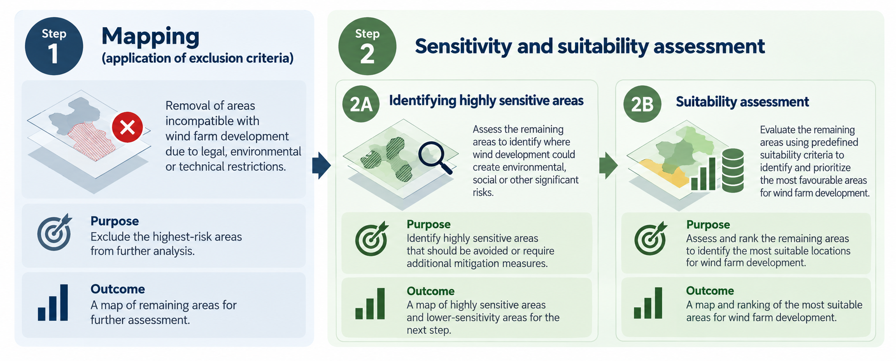

Step 1 – Mapping (application of Exclusion Criteria): During the mapping phase, exclusion criteria were applied to identify and remove areas where wind farm development could potentially result in significant adverse environmental, social, or other impacts, or where development would be incompatible with existing legal, environmental, or technical restrictions. These areas were excluded from further assessment.

The mapping process was based on the methodology and spatial information developed within the REZOMA project. As part of the preparatory work, the available spatial datasets were reviewed to identify opportunities to incorporate more accurate, up-to-date, or higher-resolution data, thereby improving the reliability and spatial precision of the assessment. In parallel, relevant legislation and regulatory requirements were reviewed to determine whether any additional exclusion criteria or changes to existing restrictions needed to be considered. This process ensured that the mapping approach was based on the best available spatial data, reflected the current regulatory framework, and provided a consistent and reliable basis for the subsequent sensitivity and suitability assessment (Step 2).

Step 2 Sensitivity and suitability assessment:
Step 2A - Identification of highly sensitive areas: Areas left after mapping were assessed against a range of environmental, social, technical, and other relevant criteria to identify locations considered highly sensitive to wind farm development. These areas were identified as requiring exclusion due to potential environmental constraints.

Step 2B - Suitability assessment: Following the identification of highly sensitive areas, the remaining locations were evaluated using a predefined assessment scale and a set of suitability criteria. This assessment enabled the comparison and classification of areas according to their suitability for wind farm development, helping to identify and prioritize the most favorable locations for further consideration.

The geospatial datasets used for this assessment were based on publicly available information obtained from major open-access databases and data platforms. These datasets provide a useful basis for preliminary spatial screening and identification of potential environmental constraints.

However, the availability and completeness of data remain limited, and additional data sources should be incorporated in future assessments to improve the accuracy and reliability of the analysis.

